Multiple-choice section – choose the correct answer

Question 1 [8.1]

A transversal line is a line that is:

A perpendicular to another line

B parallel to another line

C intersects two or more lines

D bisects another line.

Question 2 [8.2]

If one angle of a parallelogram is 110°, what are the measurements of the remaining 3 angles?

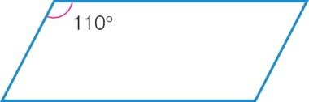

A 70°, 110°, 70° B 20°, 10°, 30° C 10°, 20°, 30° D 50°, 100°, 30°

Question 3 [8.4]

When two triangles have two angles the same and one pair of sides equal in length in corresponding positions, we say they are congruent because of:

A AAS B SAS C AAA D SSS

Question 4 [8.2]

The value of the pronumeral *x* is:

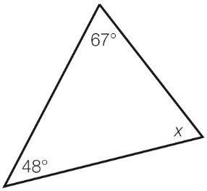

A 115° B 65° C 67° D 245°

Question 5 [8.3]

The quadrilaterals *ABCD* and *PQRS* are congruent. Which side must have the same length as *AB*?

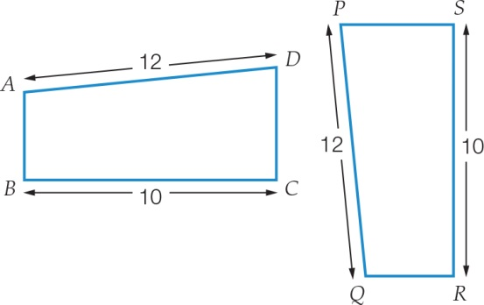

A *PQ* B *PS* C *SR* D *QR*

Question 6 [8.3]

The point (-3, -5) is a vertex of a kite.

When the kite is reflected in the *x*-axis, what are the coordinates of the image of the vertex?

A (3, -5) B (-3, -5) C (3, 5) D (-3, 5)

Question 7 [8.5]

In a kite an angle between two sides of different lengths is 88°. Another angle in the kite must be:

A 92° B 88° C 133° D 272°

Question 8 [8.5]

Which statement is true for a trapezium?

A one pair of opposite angles are equal

B diagonals bisect each other

C the shape has no side or diagonal properties

D diagonals bisect each other at right angles

Multiple-choice results: ___ /8

Short answer section

Question 9 2 marks [8.1]

State if each of the following pairs of angles is complementary or supplementary.

(a) 22° and 158° ________________

(b) 74° and 16° ________________

Question 10 3 marks [8.1]

The size of angle *AOC* is 155° and the size of angle *BOD* is 152°.

Find the size of angle *DOC*.

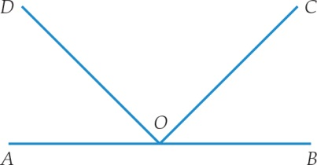

Question 11 2 marks [8.1]

Find the value of the angle *x* in the diagram. Give reasons for your answer.

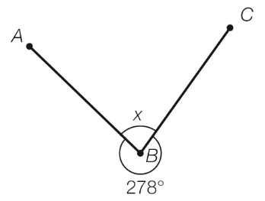

Question 12 4 marks [8.1]

Find the value of the pronumerals in the diagram. Give reasons for your answers.

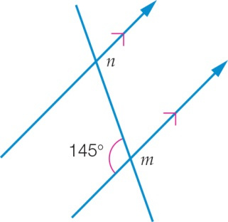

Question 13 2 marks [8.2, 8.3]

Choose the correct words from the following list to fill each of the gaps in the following sentences.

*triangle kite rectangle translation reflection rotation*

(a) A _______________ has both pairs of opposite sides equal in length.

(b) Another name for a turn is a ________________.

Question 14 6 marks [8.2]

Find the value of the pronumerals in the diagram. Give reasons for your answers.

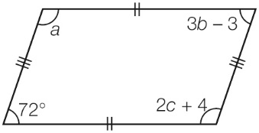

Question 15 2 marks [8.4]

State which of the triangles below are congruent and which test can be used to prove this.

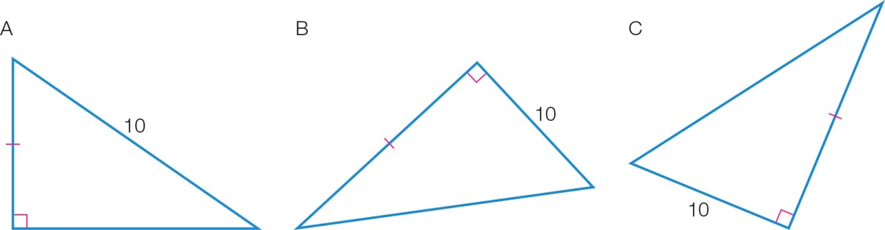

Question 16 2 marks [8.2]

What is the interior angle sum of a regular decagon?

Question 17 6 marks [8.3]

(a) Using the grid below, plot the points *A*(-5, 7), *B*(-7, 5), *C*(-6, 1) and *D*(-4, 4). Join the points to form a quadrilateral *ABCD* and label the points.

(b) Perform the translation of [6, -4] on *ABCD*.

(c) Using the shape you created in (b), perform a clockwise rotation of 90° about the point *C*′.

(d) Using the shape you created in (c), perform a reflection in the *y*-axis. What are the coordinates of this transformed quadrilateral?

*A*′′′ ____________ *B*′′′ ____________ *C*′′′ ____________ *D*′′′ ____________

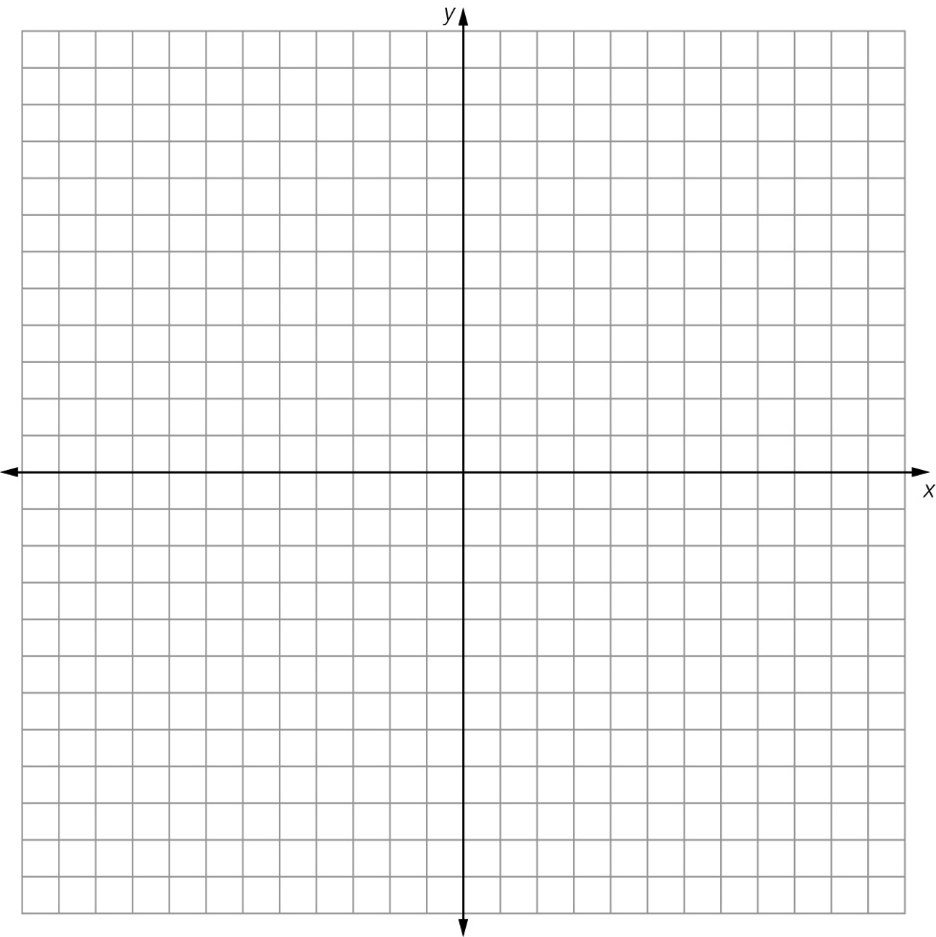

Question 18 4 marks [8.5]

Answer true or falsefor the following statements.

(a) In a trapezium the diagonals are congruent. ______________

(b) Both pairs of opposite angles in a rhombus are congruent.________________

(c) In a rectangle, both pairs of opposite sides are congruent. _______________

(d) Sides are parallel to one another in a kite. ________________

Question 19 3 marks [8.4]

Consider the following pair of triangles.

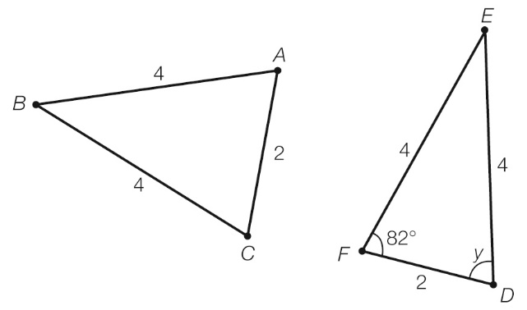

(a) Show that they are congruent.

(b) Find the value of the angle *y*.

Question 20 2 marks [8.5]

Use congruent triangles and known angle facts to find the value of the pronumeral in the quadrilateral. Give reasons for your answer.

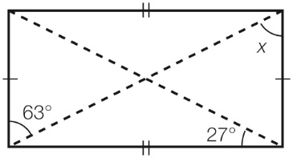

Short answer results: ___ / 38

Extended answer section

Question 21 4 marks [8.2]

A triangle has angles (*x* – 8)°, (*x*+ 12)° and (*x* + 2)°.

Find the size of each angle.

Question 22 5 marks [8.2]

(a) Find the value of the angles *a*, *b* and *c*. Give reasons for your answer.

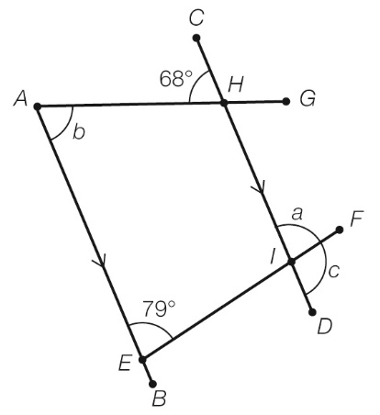

(b) What other angle(s) are equal to ∠*FID* (or *c*)?

(c) What is the size of ∠*AHI*?

Extended answer results: ___ / 9

TOTAL test results: ___ / 55